Cyclic Haloalkane Problems
Name the following structures. (Note: The structures are complex for practice purposes and may not be found in nature.)
1) 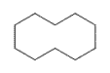 2) 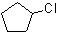 3) 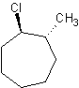 4)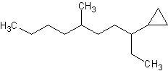
5)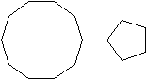 6)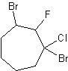

7)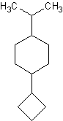
Draw the following structures.
8) 1,1-dibromo-5-fluoro-3-butyl-7-methylcyclooctane 9) 1-bromo-2-chlorocyclopentane
10) 1,1-dibromo-2,3-dichloro-4-propylcyclobutane

